**SOCIAL ANALYTICS ASSIGNMENT-1**

TANISH JAIN

R100217078

500062034

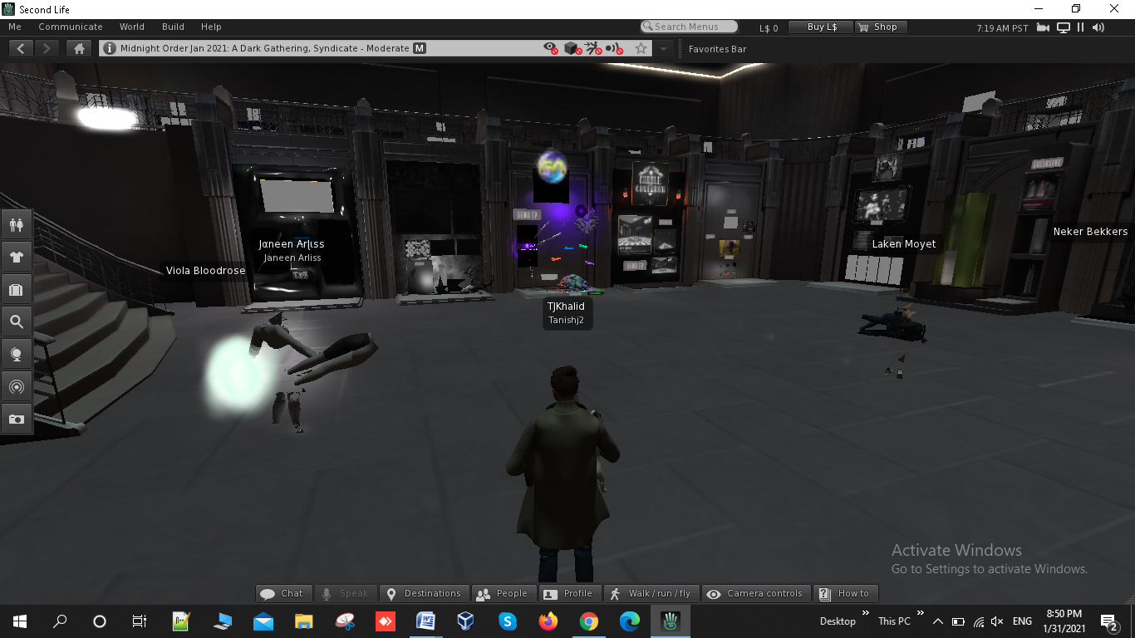

Intro Page and setup: This is the intro page which makes us familiar with the interface and controls of the application. There is a dedicated chat box to chat with other fellows

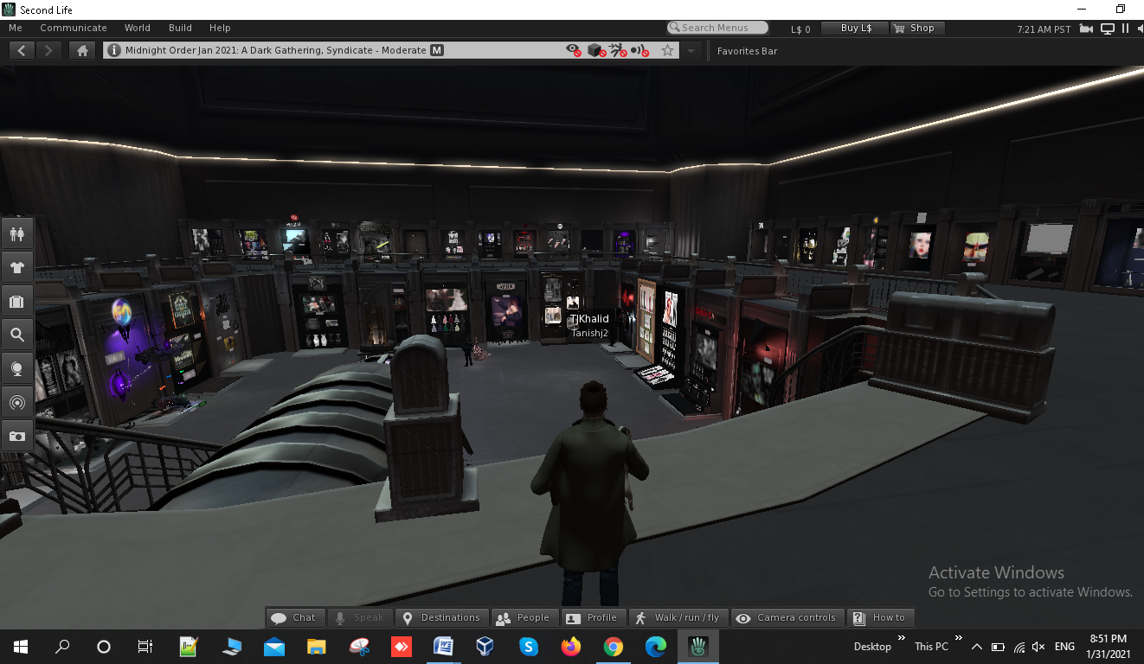

Controls: The application is completely controlled with a combination of keyboard and mouse. W,A,S,D/arrow keys to move and E to jump/ fly. The mouse will be useful in viewing different camera angles and panning to a bigger area.

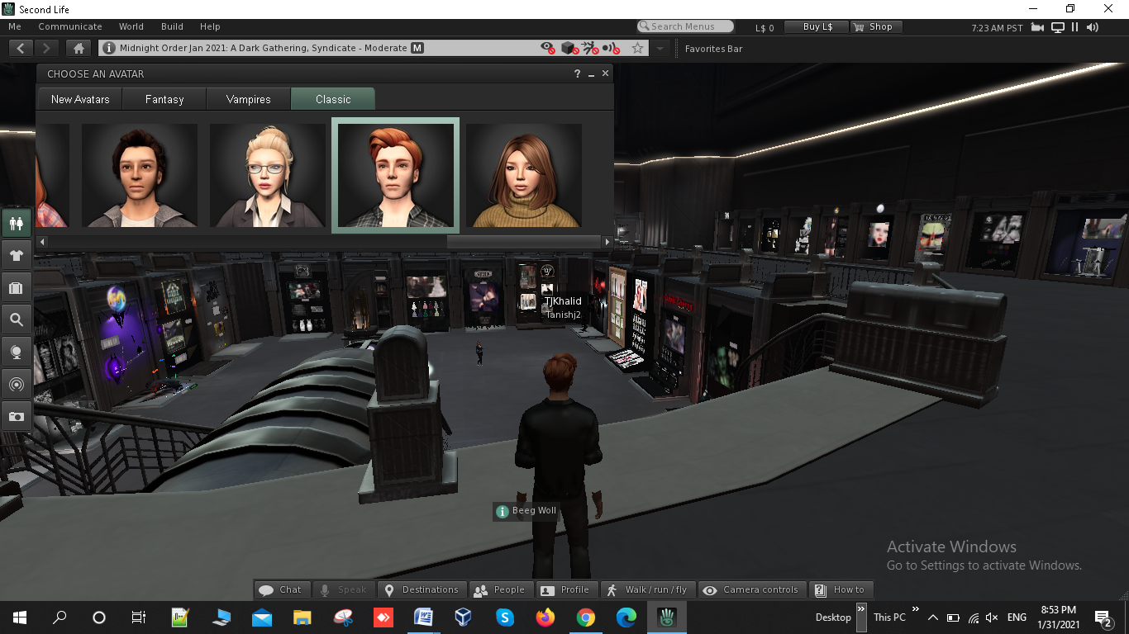

Avatar Selection:In Second Life, my character/avatar is based on classic-based characters.

I am a particular fan of the “Mid-Night / Dark” themed design which is a Mid Night Order or we can say that we youngster always get together with our friends in night, we like to party in clubs, eat, dancing, shopping and fun together.

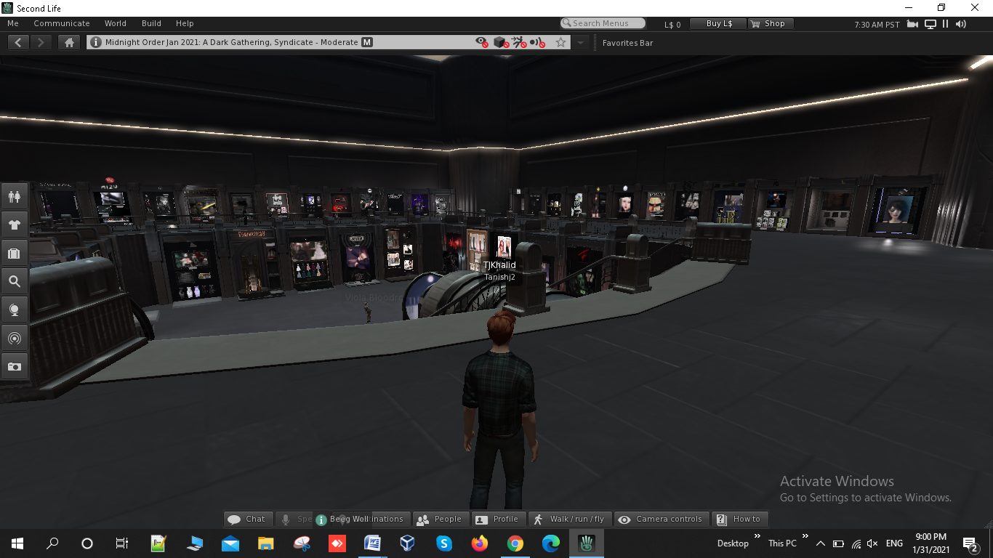

There are several different locations/ maps to choose from and walk around. The location shown in the image above is the first floor setup.